3-Checkpoint CI-CD

I- Freestyle project

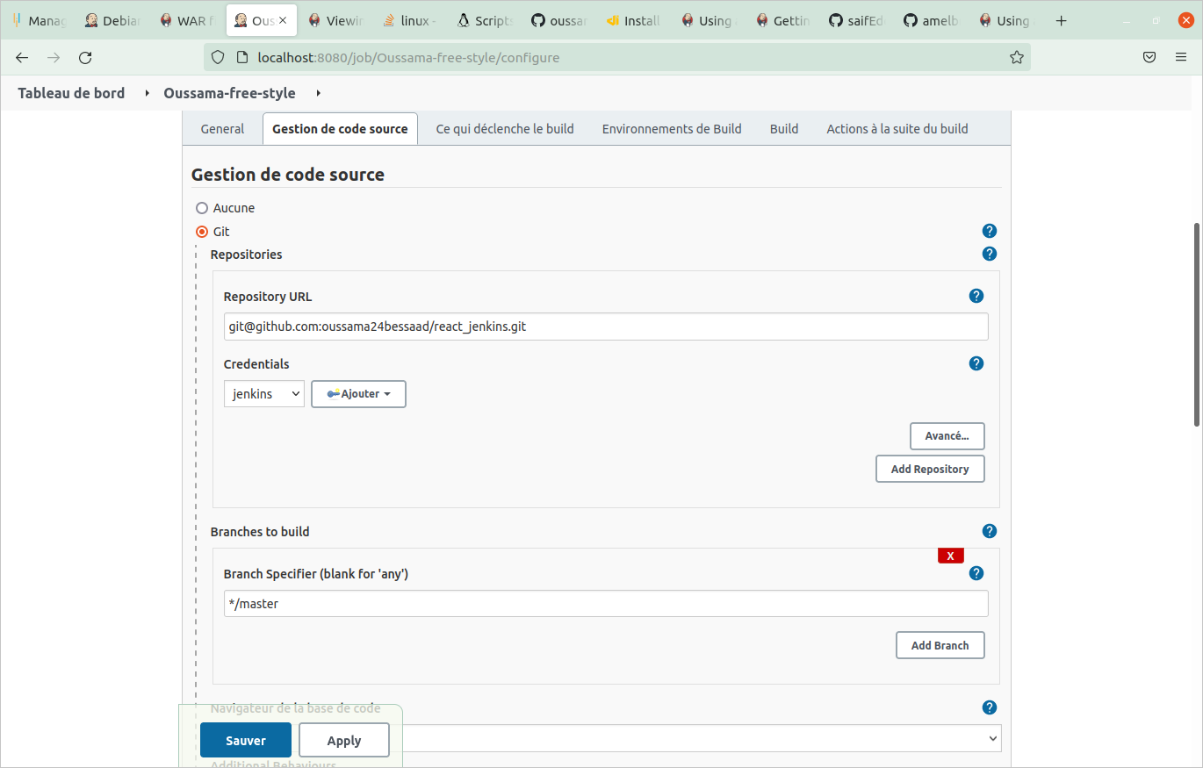

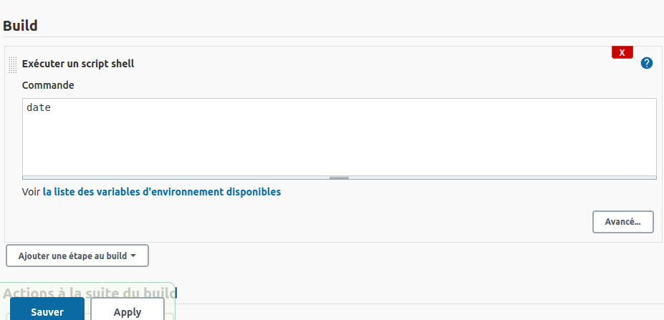

*Generate the SSH Keygin for jenkins (private) and for Github (public)
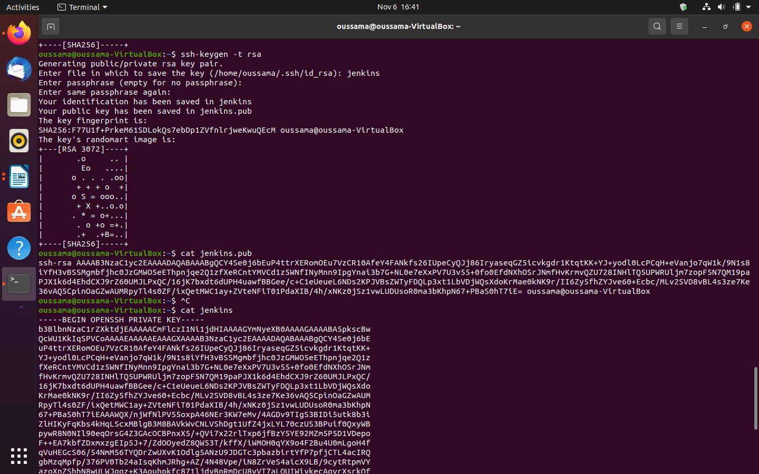

* Insert the public SSH keygin in Github
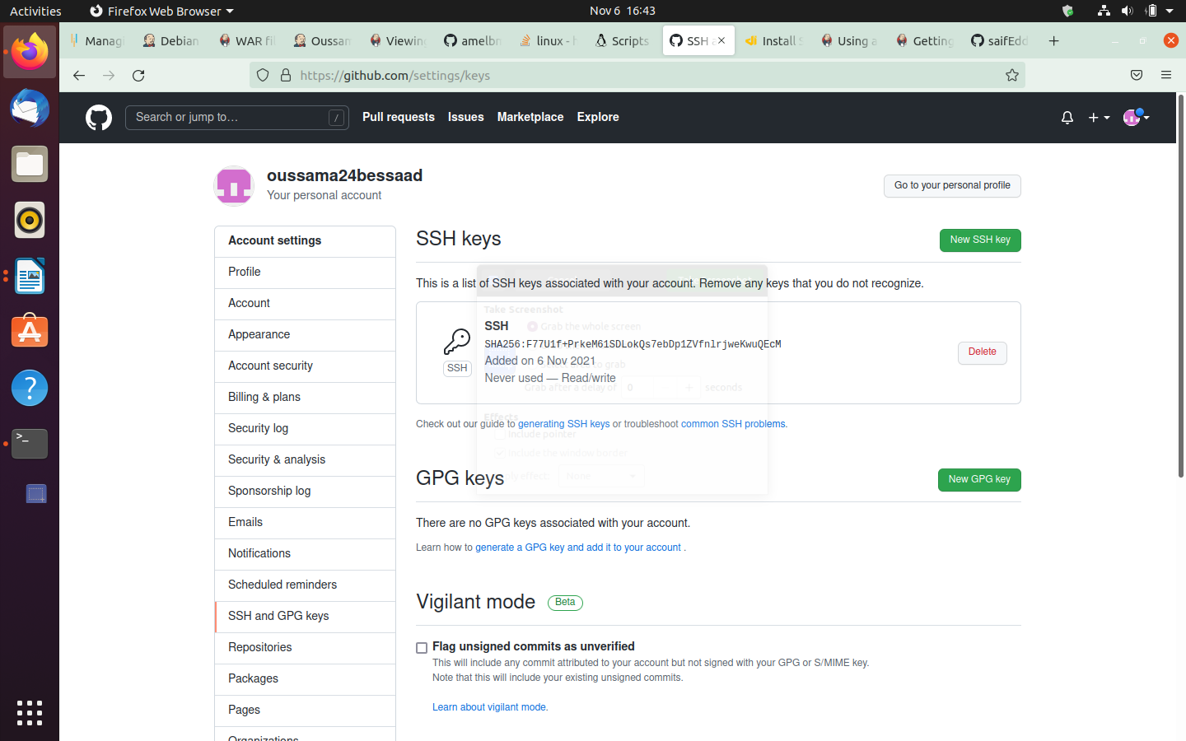

*Insert the private SSH Keygin in Jenkins:

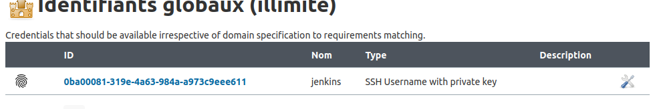

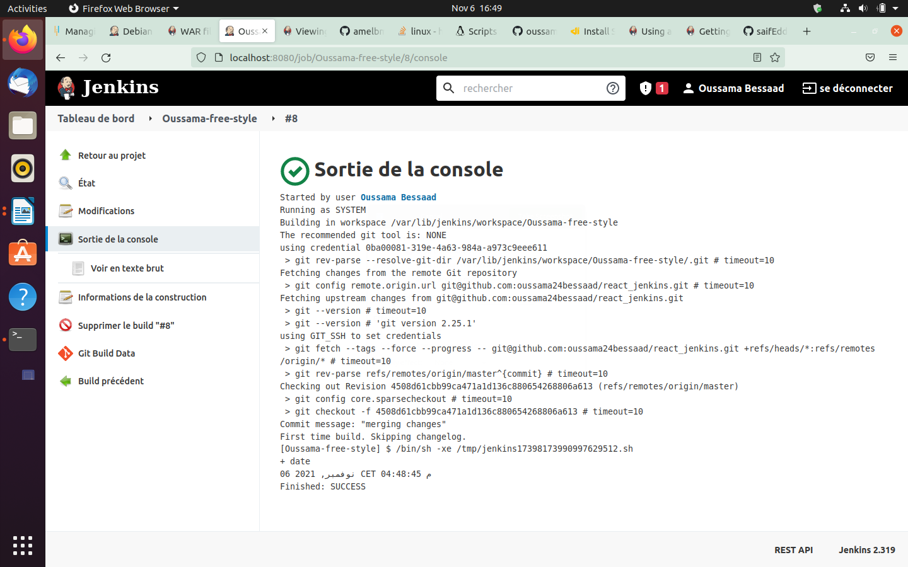

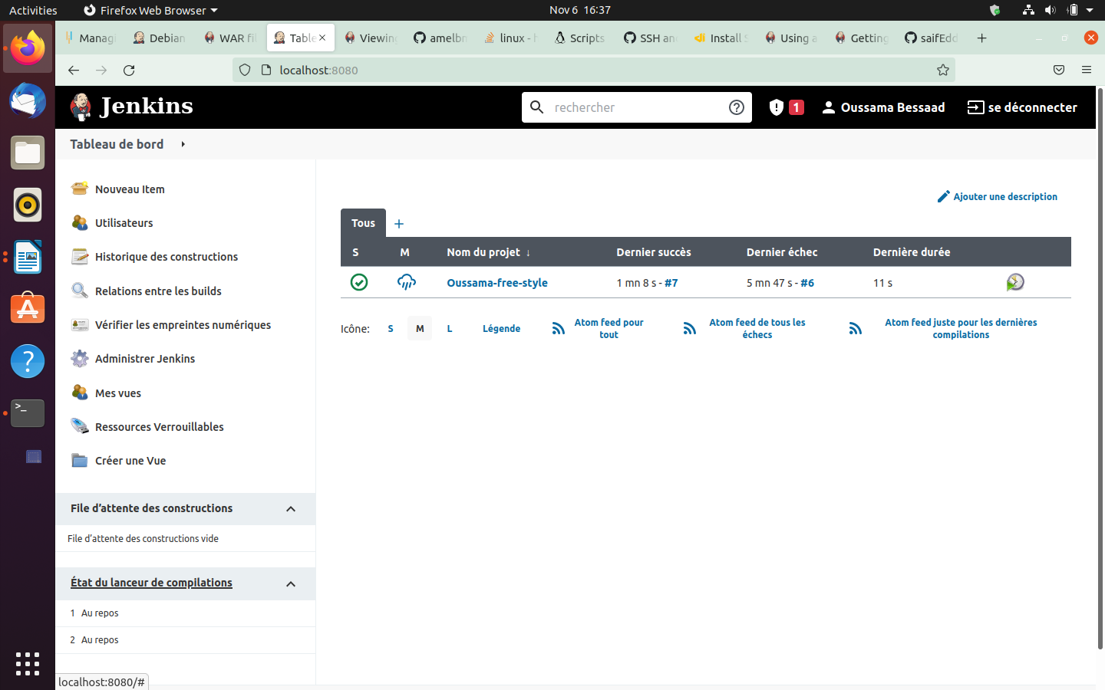

Pipeline:
1- Simple Script Shell: “date”

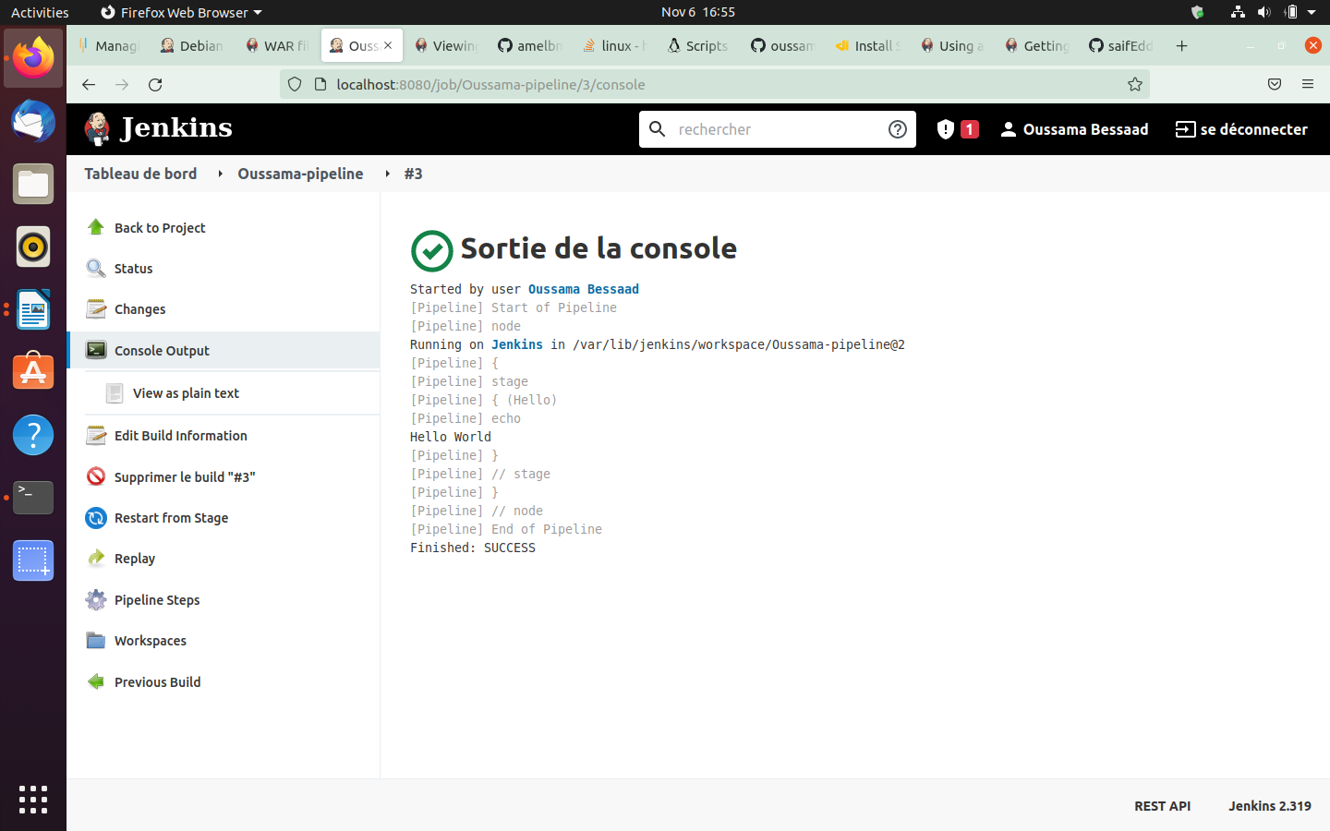

2- Jenkinsfile:
*Try a declarative Pipeline

pipeline {
agent any
stages {
stage('build') {
steps {
sh 'npm install'
sh 'npm run build'
}
}
}
}

*Jenkinsfile created and pushed to Github
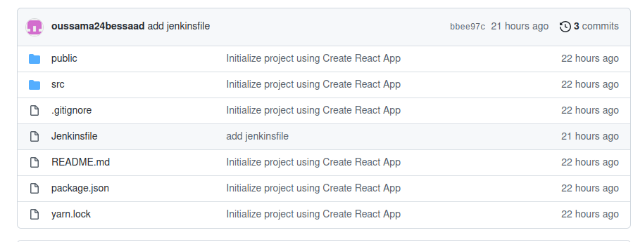

*Get Pipeline from Github
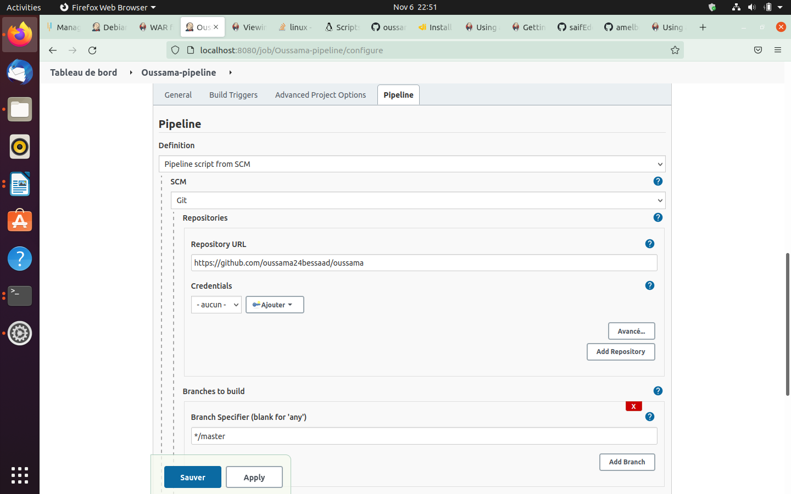

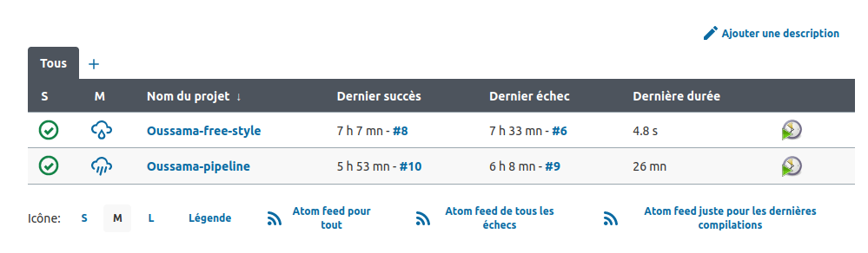

*Making The Build

